
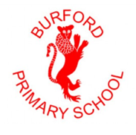
Burford Primary School
Breakfast & After School Club Booking Form
Name ……………………………………………………………………………………..….
Term or Week Beginning ……………………………………………………………
 | Breakfast Club  7.45 – 8.45  £5.25 for block booking  £6.25 for ad hoc | After School  3.15 – 4.15  £4.50 for block booking  £5.50 for ad hoc | Following Activity Clubs  4.15 – 5.30  £7.00 for block booking | After School  3.15 – 5.30  £10.00 for block booking  £11 for ad hoc
Monday
Tuesday
Wednesday
Thursday
Friday
Total

Sessions booked and not attended will be charged for unless 24 hour notice of cancellation is given. Payment to be made on ScoPay in advance please.
This form is available to download from our website to enable you to e-mail your booking requests to:- office.2251@burford-pri.oxon.sch.uk

